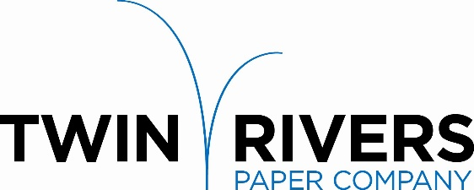

Twin Rivers Paper Company is a leader in the production of specialty papers. We are pleased to announce that our IT Department is seeking a committed individual to join our team to work full-time as a BUSINESS SYSTEMS ANALYST in our Madawaska, Maine mill.

The Business Systems Analyst’s role is to work with business leaders to improve processes and solve challenging business problems using information technology. This individual will be given a flexible approach to apply their communication, data mining and analytical skills to deliver solutions to the company.

Responsibilities:
- Technical Skills
  - Working knowledge and/or desire to work with AS400 systems
  - Develop and maintain SQL queries, views and stored procedures to mine data and integrate data across multiple systems
  - Provide reporting and analytics using modern BI tools like PowerBI and SSRS
  - Strong desire to commit to a continuous learning process using various resources
  - Become a champion for advancing new technologies into Twin’s long term IT strategy

- Application Management
  - Assist in the definition, development, and documentation of software business requirements and objectives in collaboration with internal business stakeholders
  - Research and engage with leading technology providers to understand best practices while addressing business priorities
  - Support Applications such as:
    - GL / Financials
    - Maintenance / Accounts Payable
    - Production Tracking
    - SharePoint / O365

- Project Management
  - Partner with business leaders to understand how business functions can leverage software solutions
  - Manage a business priority and demand status process to communicate progress to key stakeholders

Requirements:
- College diploma or university degree or minimum of 5 years related work experience
- Experience with SQL Server including triggers, functions and stored procedures
- Experience with AS400 and/or confidence and desire to within an AS400 environment
- Strong desire to continue a continuous learning path forward
- Strong project and time management skills, ability to prioritize multiple issues in the execution of priority requests
- Ability and desire to travel to selected facilities to work closely with key stakeholders

Twin Rivers Paper offers a competitive salary and an extensive benefit package. Please send your letter of interest and resume to:

Twin Rivers Paper Company, HR Department
82 Bridge Avenue, Madawaska, ME 04756
Or by Email: careers@twinriverspaper.com

Deadline is February 10, 2023

Twin Rivers is an equal opportunity employer. All qualified applicants will receive consideration without regard to race, color, religion, gender, national origin, disability status, protected veteran status, or any other characteristic protected by law.

