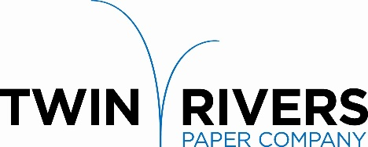

Twin Rivers Paper Company is a leader in the production of specialty papers. We are pleased to announce that we are seeking a committed individual to join our team and grow their career as a full-time

Licensed Millwright

Reporting to the Maintenance Supervisor, the Licensed Millwright is responsible for:
- Working with a growing and highly motivated team in a fast-paced environment
- Carrying out duties assigned by the maintenance supervisor
- Completing scheduled work and Preventive Maintenance work(PM) work
- Troubleshooting and repairing equipment problems
- Keeping detailed and accurate maintenance reports and documentation
- Repairing or replacing chains; belt conveyors; gear boxes/drive chains; hydraulic & pneumatics; welding/cutting and using power tools
- Adhering to workplace safety policies, regulations, and compliance
- Other duties and responsibilities as assigned pertaining to the job

Requirements:
- Red Seal Journeyperson
- Previous experience in an industrial environment, sawmill preferred
- Excellent safety record and strong work ethic
- Strong interpersonal skills are required
- Ability to work shift and weekends

Twin Rivers Paper offers a competitive salary and an extensive benefit package. Please send your letter of interest and resume to:

Twin Rivers Paper Company - Human Resources Department
31 Renous Road, Plaster Rock NB, E7G 4B5
Or by Email: plasterrockjobs@twinriverspaper.com

Applications will be accepted until the position is filled.

Twin Rivers is an equal opportunity employer, and all qualified applicants will receive consideration without regard to race, color, religion, gender, national origin, disability status, protected veteran status, or any other characteristic protected by law.

