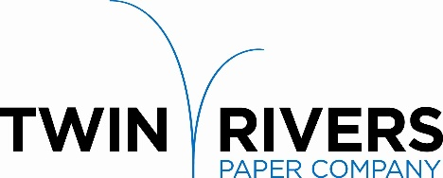

Twin Rivers Paper Company is a leader in the production of specialty papers. We are pleased to announce that our Madawaska Operation is seeking a committed individual to join our team and grow their career as a full-time

**PRODUCT sTEWARDSHIP MANAGER**

**Reporting to the Technical Director, the Product Stewardship Manager is responsible to:**

* Actively support and promote safe work practices throughout the mill by being present at safety activities and personally encouraging safe behaviors
* Enforce policies regarding health and safety as well as the environment and ensure that issues are dealt with as efficiently as possible, so the work environment is safe for employees
* Answer regulatory and forestry requests from customers
* Create and maintain Regulatory Data Sheet (RDS) forms
* Assess compliance for intended use of chemicals
* Approve trial memo forms for environmental and product stewardship
* Approve trial memo and management of change forms for environmental and product stewardship
* Coordinate annual testing for FDA compliance
* Maintain Kosher certification
* Organize documentation and manage submissions for BPI certification
* Assign testing for particular chemicals of concern or regulatory tests
* Gather and update regulatory information from suppliers
* Develop procedures and training for Madawaska and New York personnel for forestry sustainability
* Maintain Credit Table accounting and Sulfite credit tracking
* Respond to customer surveys (quality and regulatory)

**Requirements:**

* Bachelor’s Degree and/or equivalent experience
* Experience in pulp and paper industry
* Computer skills to include Excel, Word, and PowerPoint.

Twin Rivers Paper offers a competitive salary and an extensive benefit package. Please send your letter of interest and resume to:

Twin Rivers Paper Company - Human Resources Department

82 Bridge Avenue, Madawaska, ME 04756

Or by Email: [madawaskajobs@twinriverspaper.com](mailto:madawaskajobs@twinriverspaper.com)

# Applications will be accepted until the position is filled.

Twin Rivers is an equal opportunity employer, and all qualified applicants will receive consideration without regard to race, color, religion, gender, national origin, disability status, protected veteran status, or any other characteristic protected by law.