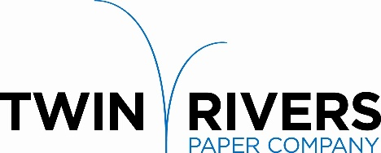

Twin Rivers Paper Company is a leader in the production of specialty papers. We are pleased to announce that our New York Operation is seeking a committed individual to join our team and grow their career as a full-time:

Quality Specialist

Reporting to the Director of Product Development, the Quality Specialist will:
Support the quality department to ensure work is accomplished in an effective and timely manner. Participate in audits, surveys and analysis of data to prepare required reports. Contribute to employee training and certification. Communicate to plant, management, customers and suppliers. Generate and maintain documents in support of ISO 9001-2015 and the Food Safety Program.

Responsibilities will include:
- Maintain raw material compliance data base and provide compliance records to plants, product development and purchasing
- Track Certificate of Analysis performance data related to raw materials
- Support ISO 9001-2015 corporate efforts including maintenance of audit plans and schedules, SOP reviews and document updates.
- Create requisitions, process paperwork related to Vendors, follow-up on open purchase orders and verify invoices to PO.
- Receive and track complaint feedback-credit paperwork and process through the required approval process.
- Track QA budget spending information.
- Create management reports for QA and related departments
- Compile data for reports, enter into excel spreadsheet and perform required calculations
- Resolve issues that may occur while performing responsibilities
- Maintain quality records system
- Set-up ISO training schedules, prepare and distribute training documents, maintain training records
- Perform all duties to a high degree of accuracy and detail.
- Develop executive summaries for complaints and credit request
- Observe and follow plant rules for safety and Food Safety
- Supply product stewardship compliance letters to customers as requested
- Maintain audit traceability program at NY paper mills.

Requirements:
- Associate degree or HS Diploma with experience in Manufacturing.
- 3+ years’ experience with ISO Quality Systems and GMP/Food Safety is preferred.

Twin Rivers Paper offers a competitive salary and an extensive benefit package. Please send your letter of interest and resume to:
Amanda Hobin
Twin Rivers Paper Company - Human Resources Department
501 West Main Street, Little Falls, NY 13365
Or by Email: newyorkjobs@twinriverspaper.com

Applications will be accepted until December 22, 2022
Twin Rivers is an equal opportunity employer, and all qualified applicants will receive consideration without regard to race, color, religion, gender, national origin, disability status, protected veteran status, or any other characteristic protected by law.

