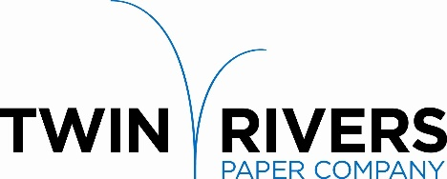

Twin Rivers Paper Company is a leader in the production of specialty papers. We are pleased to announce that our Madawaska Operation is seeking a committed individual to join our team and grow their career as a full-time

Steam Plant Supervisor

Reporting to the Engineering & Maintenance Manager, the Steam Plant Supervisor is responsible to:
- Actively support and promote safe work practices through the mill. Conduct monthly safety meetings and perform safety audits.
- Oversee work of operating staff and training of new employees.
- Inspect the entire plant, boiler rooms, auxiliary equipment, and related areas to ensure conditions are normal, operating within appropriate safety standards, and ensuring maximum efficiency.
- Review blueprints and coordinate with the Maintenance Manager for outside contractual maintenance and construction work.
- Plan and coordinate operational work distribution and budgetary requirements.
- Schedule and supervise the overhaul and cleaning of boilers, repairing of pumps, mechanical equipment, condensate return system, servicing of diesel and electrical motors and engines.
- Prepare various reports required by the Department of Environmental Protection (DEP) and the Environmental Protection Agency (EPA) concerning air quality, steam plant, etc. in coordination with Environmental Manager.
- Ensure all personnel are trained and comply with all appropriate protective and safety requirements in the performance of duties.
- Prepare justifications and requisitions for tools, equipment and supplies for the Steam Plant.
- Recruit, select, onboard, and train employees to ensure role responsibilities and expectations are clearly understood while providing opportunities to continue professional development.
- Set expectations, measure progress, provide ongoing feedback, and evaluate the performance of employees. Ensure work adheres to quality standards, deadlines, and proper procedures.
Requirements:
- High school diploma or equivalent.
- Four (4) years of full-time experience in industrial operations, including supervisory experience in the above areas.
- Current State of Maine High Pressure Boiler Operator license to level of 1st or 2nd Class Engineer.

Twin Rivers Paper offers a competitive salary and an extensive benefit package. Please send your letter of interest and resume to:

Twin Rivers Paper Company - Human Resources Department
82 Bridge Avenue, Madawaska, ME 04756
Or by Email: madawaskajobs@twinriverspaper.com

Applications will be accepted until the position is filled.

Twin Rivers is an equal opportunity employer, and all qualified applicants will receive consideration without regard to race, color, religion, gender, national origin, disability status, protected veteran status, or any other characteristic protected by law.

